**Project Report**

|  |  |
| --- | --- |
| **Project Name** | **IoT Based child safety gadget and monitoring and notification** |
| **Team ID** | **PNT2022TMID50609** |
| **Team Members** | **SELSHIA M (TL)**  **SANDHIYA SUBASHREE M**  **BANUPRIYA K**  **SUBHASHINI G** |
| **Date** | **19-11-2022** |

**CHAPTER – 1**

**INTRODUCTION**

* 1. **Project overview**

The internet of things (IoT) refers to the set of devices and system that stay interconnected with real-world sensor and to the internet. During years’ Child safety is under threat and it is very important to provide a technology-based solution which will help them under panic situations and monitor them using a smart gadget. The proposed system is equipped with GSM and GPS modules for sending and receiving call and SMS between safety gadget and parental phone, the proposed system also consists of Wi-Fi module used to implement IoT and send all the monitoring parameters to the cloud for android app monitoring on parental phone. Android application can be used to track the current location of safety gadget using its location coordinates on parental phone android app and also via SMS request from parent phone to safety gadget. Panic alert system is used during panic situations and automatic SMS alert and phone call is triggered from safety gadget to the parental phone seeking for help and also monitored for plug and unplug from hand, as Child safety is definitely something you must prioritize when providing a safe and secure home for your baby or young children. Childproofing can be quite the challenge as it can be easy to overlook impending danger around the home. From child safety gates to car seats, we’ll give you a few ideas you can add to your child protection checklist. Children today confront a variety of issues, which has led us to develop a project to safeguard them in every way. We will implement this project in hardware in the coming months.

**1.2 Purpose**

The major goal is to safeguard children from dangerous situations. For example, if a youngster approaches a fire, our device will alert their parents.

**CHAPTER-2**

**Literature Survey**

**2.1 Existing Problem**

All children are different and display unique behavioral characteristics. However, when their behaviors become challenging, parents start exploring child behavior problems and solutions.

On most occasions, children are considered to have normal behaviors if they are age-appropriate and do not cause any harm. However, if their actions become difficult to manage, you should pay attention to them. For example, if children become emotional too often, cause destruction, or behave rudely, it may signify a behavioral issue. **You can handle most of these issues with positive parenting and behavioral therapy**. Further, it is important to talk to your children and support them in overcoming the problem. However, if you feel the problem is becoming unmanageable, consider taking professional help[1].

This post elaborates on the common behavioral problems in children, their signs and symptoms, and tips for handling them efficiently. There is no yardstick for normal behavior. Instead, it depends on a child’s age, personality, emotional development, and upbringing environment.

**In general, a child’s behavior is deemed to be normal if it is socially, developmentally, and culturally appropriate**. You can consider a child’s behavior normal even if it does not meet societal or cultural expectations, but is otherwise age-appropriate and not harmful. The below problems also facing by the children,

1. They struggle with memory.

2. They play with fire fearlessly

3. An animal phobia

4. They play in water areas

5. It is simple for strangers to kidnap children.

**2.2 Problem Statement Definition**

* It is the device for child safety.
* It is used to protect kids from dangers including strangers, water, fire, and borewells.
* The kidnapping attempt by strangers was prevented. Likewise, stay away from the borewell.
* It guards against fires that could damage children and keeps them safe.
* They also have river game

**REFERENCES**

[1] <https://www.ijraset.com/research-paper/wearable-safety-device-for-children>

**CHAPTER-3**

**IDEATION AND PROPOSED SOLUTION**

**3.1 EMPATHY MAP CANVAS**

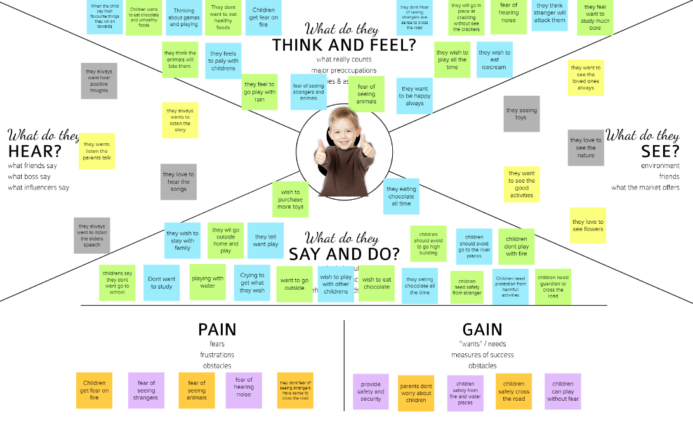

Fig 3.1 – Empathy canvas

**3.2 IDEATION AND BRAINSTORMING**

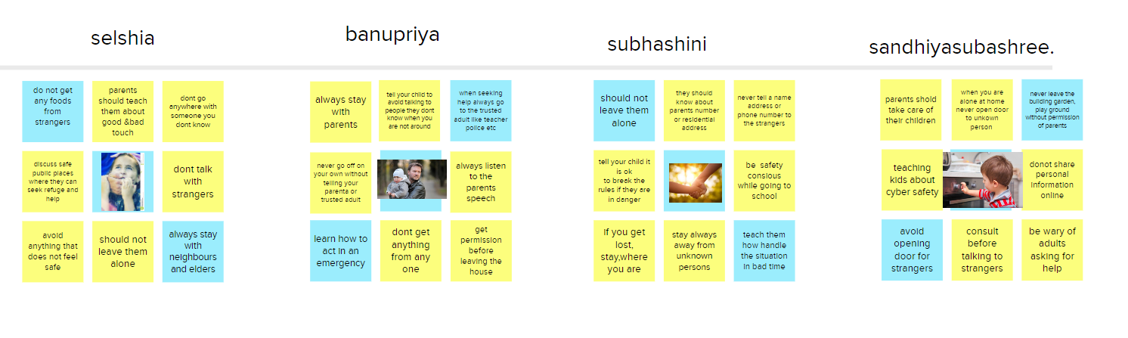

Fig 3.2- Ideation and brainstorming

**3.3 PROPOSED SOLUTION**

**Table 3.1 Proposed Solution**

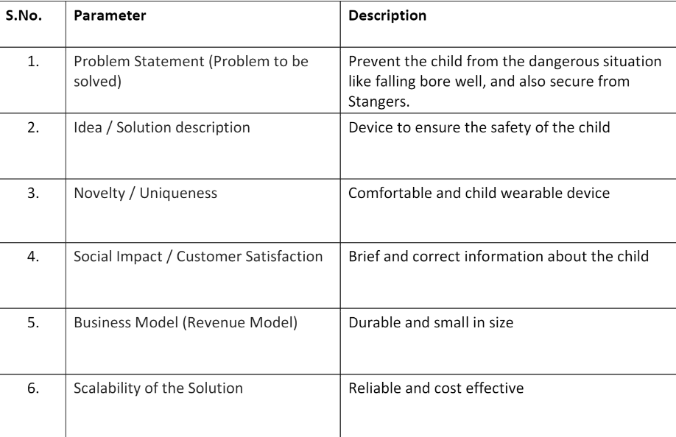

**3.4 Problem Solution Fit**

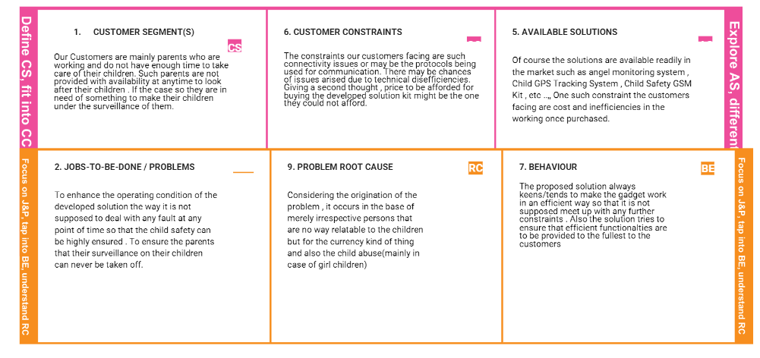

Fig 3.3 – Problem Solution Fit

**CHAPTER-4**

**REQUIREMENT ANALYSIS**

**4.1 FUNCTIONAL REQUIREMENT**

**Table 4.1 FUNCTIONAL REQUIREMENT**

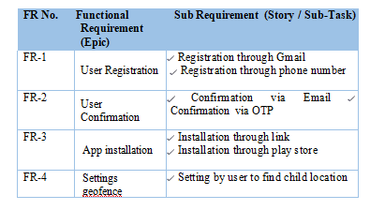

**4.2 NON- FUNCTIONAL REQUIREMENT**

**Table 4.2 NON- FUNCTIONAL REQUIREMENT**

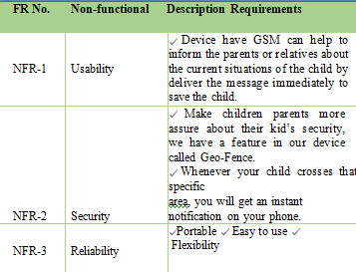

**CHAPTER-5**

**PROJECT DESIGN**

**5.1 DATAFLOW DIAGRAM**

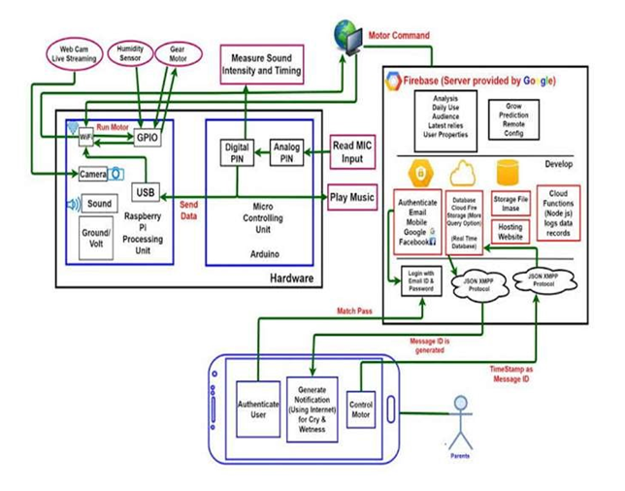

Fig 5.1 Dataflow diagram

**5.2 SOLUTION & TECHNICAL ARCHITECTURE**

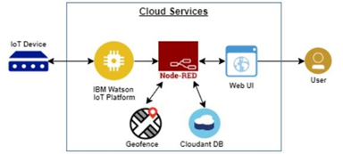

Fig 5.2 Technical architecture

IoT device, IBM Watson IoT platform, node red, web UI, geofence, and Cloudant DB were used in our solution

Our project's child safety gadget will alert parents and deliver information to them. For instance, if a child is injured after falling off of his bicycle and no one notices him, the situation can be avoided with the help of our initiative

**5.3 User Stories**

* A child who is playing outside will leave his parent's line of sight.

The nearby borewell is not anything he noticed.

Let's assume he tumbles.

By using our device, users may avoid these scenarios altogether, protecting their children from harm.

* Another illustration is a toddler who is unaware of electricity.

They may touch switches or electrical devices while playing at

home.

We use our project to prevent these kinds of occurrences.

**CHAPTER-6**

**PROJECT PLANNING AND SCHEDULING**

**6.1 SPRINT PLANNING AND ESTIMATION**

**Table 6.1 Sprint Planning And Estimation**

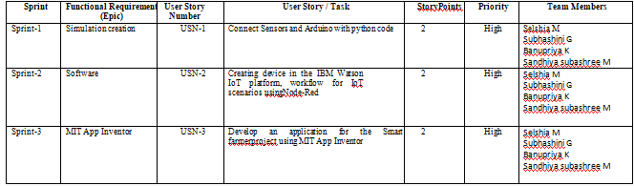

**6.2 SPRINT DELIVERY SCHEDULE**

**Table 6.2 Sprint Delivery Schedule**

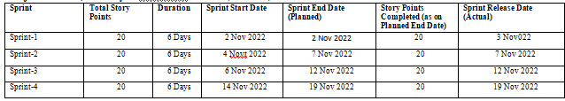

**CHAPTER -7**

**CODING AND SOLUTIONING**

**7.1 FEATURE 1**

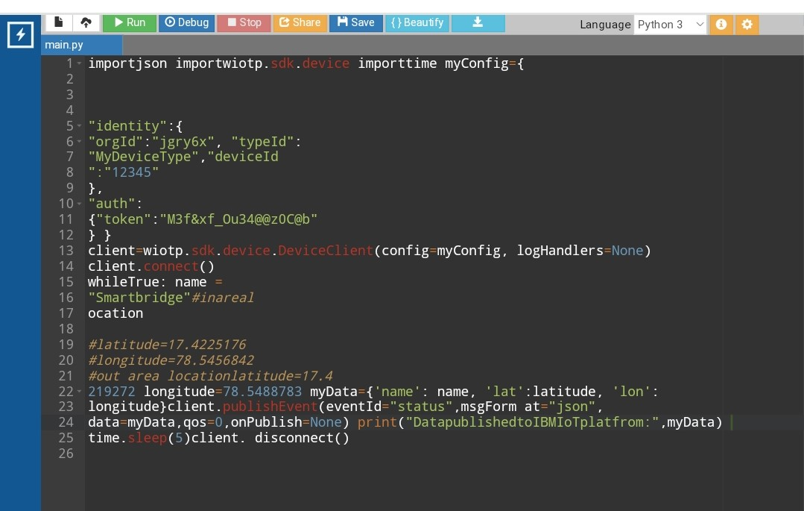

Fig 7.1 Compilation

**OUTPUT**



Fig 7.2 Output

**7.2 FEATURE 2**

Child safety device is know for The LinkIt ONE board is an open source platform. It consists of inbuilt Wi-Fi, GSM, GPS and Bluetooth modules.

The link it one board is similar to the arduino board and it is termed as all-in-one prototyping board for wearable’s and IoT devices. The board consists of ARM7 EJ-S and the clock speed is 260MHz.

A SIM and SD card slots are provided on the board itself. For the audio purpose a headset slot is also provided. The link it one is a robust development board for the hardware and also used for industrial applications.

Different components such as Temperature sensor, Touch sensor, heartbeat sensor, GSM, GPS modules and serial camera are connected to the LinkIt ONE Board along with builtinGSM, GPS modules.

Lithium ion battery is used as DC supply required to energize it. A rechargeable battery can also be used for the above purpose. Temperature sensor block is shown in figure 1; temperature is one of the most commonly measured variables and is therefore there are many ways of sensing temperature.

For measuring body temperature of the child LM35 temperature sensor is used. The touch sensor has three main components on the circuit board.

The first component comprises of resistors, transistors, capacitors, inductors, and diodes whose area is measured physically and its analogue signal is sends to an amplifier. Depends upon the resistant value of the potentiometer the amplifier amplifies the signal and sends the signal to analogue output of the module.

The third component is comparator, when the signal falls under a specific value it is used to switch the output. A serial camera is used for the purpose of taking snapshot of the area surrounding the child.

A miniature TTL serial JPEG camera is used because it is the best one for the purpose of wearable type. The camera can snap the images of different sizes of pixels and those images are pre-compressed into JPEG images.

The heartbeat sensor is used in the proposed system for measuring the pulse rate. There is a heartbeat pulse sensor which is combined to simple optical heart rate sensor with amplification and nullification circuitry making it is fast and easy to get reliable pulse reading.

The GSM/GPRS block is activated with a SIM card on the board. GSM standard used here is GSM900. They mainly differ‘s based on bandwidth and RF carrier frequency.

GSM network consists of mobile station, Base station subsystem network and operation subsystem. The GPS module is provided for identifying the location of the child. GPS module receives the signals from satellites which are located miles away.

The latitude and longitude of the location can be identified by the GPS module. The Link it ONE board consists of micro SD/SIM combo.

The device sends the monitored parameters data such as Temperature, touch and pulse rate to cloud. When there are any abnormalities in temperature or touch or pulse rate readings, a SMS is sent to the parent/caretaker mobile phone immediately.

After sending SMS the serial camera captures the International Journal of Innovative Technology and Exploring Engineering (IJITEE) ISSN: 2278-3075, Volume-8 Issue-8 June, 2019 1793

Published By: Blue Eyes Intelligence Engineering Retrieval Number H6836058719/19©BEIESP & Sciences Publication snapshot in real time and is stored in SD card. From the SD card through the GSM module an MMS is sent to the particular mobile phone.

**7.3 DATABASE SCHEMA**

Child Health Monitoring Using Sensor Technology is a framework to support a unique health care for children. Using this framework the parents and other related persons who take care the child’s and keep intense monitoring on the children’s physical health condition from anywhere.

This framework also can be used to reduce or prevent things that can be harmful for children’s health, grow, and development progress. The CHC (Child Health Care) will be provides many features and such as notification and monitoring system to a professional health care of school as well as parent, based on the children (student) record.

This framework will improve the children’s health, grow and development progress.

With the rapid development of urbanization and industrialization in China, more and more children are studying and living in cities, which presents some safety challenges.

To help guardians better monitor their children, the authors present Child Guard, a child safety system based on mobile devices. Child Guard provides an in-path safety function that monitors the real-time movement of children walking on the road.

It also provides a region safety function that sets designated areas in which children can play. Children can be warned about potential risks, and their guardians can be informed of location or activity abnormities. Experiments show that Child Guard has higher positioning accuracy and better real-time communication than similar systems. This article is part of a special issue on cyber security.

To help guardians better monitor their children, the authors present Child Guard, a child safety system based on mobile devices. Child Guard provides an in-path safety function that monitors the real-time movement of children walking on the road. It also provides a region safety function that sets designated areas in which children can play.

**CHAPTER – 8**

**TESTING**

**8.1 TEST CASES**

Today in introduce universe of advanced innovation and worldwide figuring each individual is associated with each other in number of ways. In current worldwide figuring world, the youngsters and ladies provocation, chain snatchings, hijacking, lewd activities, eve prodding, and so forth are expanded step by step, winding up more perilous and powerless.

At the point when these risky circumstances happen there must be an inclining innovation to be agreeable to deal with. So we are proposing a framework that takes a shot at the debate of youngsters utilizing IOT.

In this venture we proposed a gadget which is incorporated with different gadgets, containing wearable "Action Tracker Wrist Band" which is modified with all the required information which incorporates the conduct of human Health is fundamental need and it is human right to get quality Health Care.

Nowadays India is facing many health issues because of less resource. This review paper presents the idea of solving health issues using latest technology, Internet of Things. It presents the architectural review of smart health care system using Internet of Things which is aimed to provide Quality Health Care to everyone.

Using this system architecture, patients' body parameters can be measure in real time. Sensors collects patients body parameters and transfers that data to Arduino Uno which further transfer that data to cloud with the help of WiFi module.

This data is stored into Thingspeak database server which manages data and provides accessibility. User can view this data with the help of Android App.

This work mainly focuses on alerting the individuals arround baby so as to locate the baby in safer zone before arrival of the parent. Among all the available wearable devices focusing on the conditions to provide the locality, action and so forth of the child to the parents via wireless Wi-Fi and Bluetooth, Bluetooth and Wi-Fi (wireless fidelity)becomes a very inconsistent resource to the communication.

**CHAPTER-9**

**RESULTS**

**9.1 PERFORMANCE METRICS**

Performance metrics are defined as figures and data representative of an organization's actions, abilities, and overall quality.

Performance measurement is the process of collecting, analyzing and/or reporting information regarding the performance of an individual, group, organization, system or component.

Definitions of performance measurement tend to be predicated upon an assumption about why the performance is being measured.

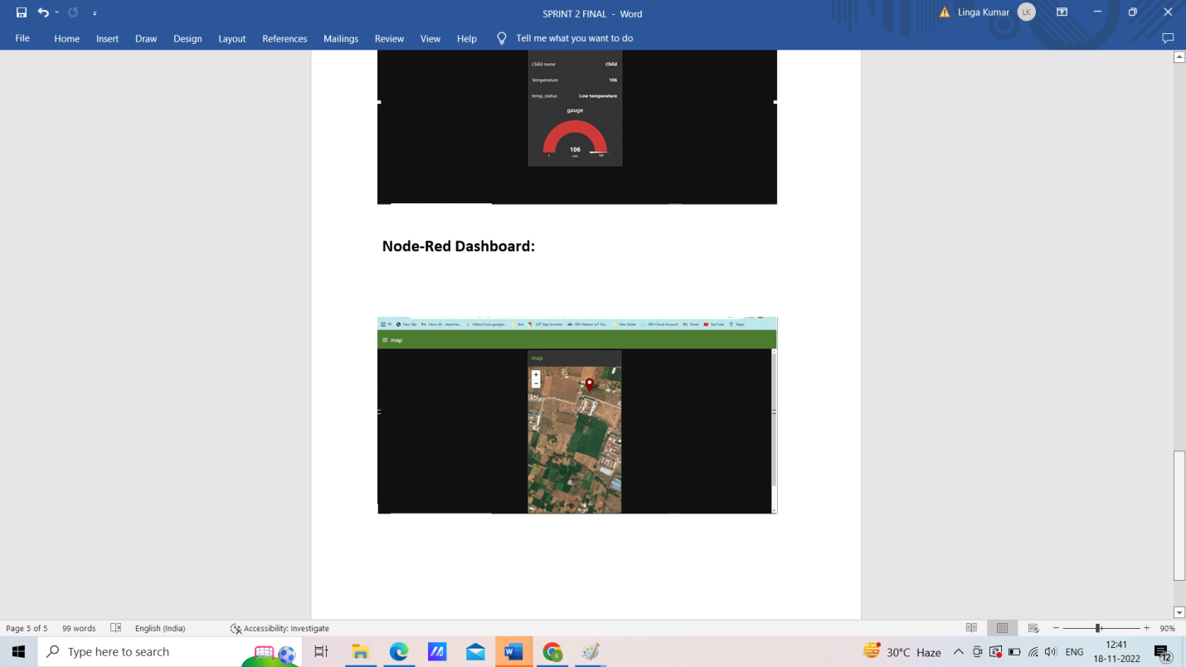

**CHAPTER-10**

**ADVANTAGES & DISADVANTAGES**

**ADVANTAGES**

* The primary advantage is guardians will continuosly screen the child playing area ,whereas they playing exterior the home
* Child security contraption continuosly give safe and security
* We have to check the children distance away from the fire
* We keep the children absence from the water tank
* Children continuosly play with security checking contraption
* Parents don't need to worry about their kids
* Children commute safely to and from school and vice versa
* Children can always have fun while playing.

**DISADVANTAGES**

* + The main disadvantage is Technical issues could occur.
  + Water damage to the object
  + Data security issues could be risky.

1

**CHAPTER -11**

**CONCLUSION**

This research demonstrates Smart IoT device for child safety and tracking, to help the parents to locate and monitor their children. If any abnormal readings are detected by the sensor, then an SMS and phone call is triggered to the parents mobile. Also , updated to the parental app through the cloud.

The system is equipped with GPS modules for sending and receiving call, SMS between safety gadget and parental phone. The system also consists of Wi-Fi module used to implement IoT and send all the monitored parameters to the cloud for android app monitoring on parental phone. Panic alert system is used during panic situations alerts are sent to the parental phone, seeking for help also the alert parameters are updated to the cloud.

**CHAPTER-12**

**FUTURE SCOPE**

This system can be further enhanced by installation of mini camera inside smart gadget for better security so that live footage can be seen on parental phone during panic situations. The system can be modified by installation of small solar panels for charging the battery of smart gadget to gain maximum battery backup.

This system requires network connectivity satellite communication and high speed data connection when we use web camera and GPS to lively monitor. It is difficult to monitor when there any hindrance to satellite communication or any network issues. There also occurs time delay in video streaming through the server hence in the future these issues can be overcome by using zigbee concept or accessing the system without internet and using high speed server transmission.

**CHAPTER-13**

**APPENDIX**

**SOURCE CODE**

import time import sys

import ibmiotf.application import ibmiotf.device import random

#Provide your IBM Watson Device Credentials organization = "zwx6lb" deviceType="nodeMCU" deviceId = "12345678" authMethod = "token" authToken = "12345678"

#api key {a-illza1-mbdxqo6z0s}

#api token {zSYzISuAWF&F_x7GkT}

try:

deviceOptions = {"org": organization, "type": deviceType, "id": deviceId, "auth-method":

authMethod, "auth-token": authToken} deviceCli = ibmiotf.device.Client(deviceOptions)

#.............................................. except Exception as e:

print("Caught exception connecting device: %s" % str(e)) sys.exit()

# Connect and send a datapoint "hello" with value "world" into the cloud as an event of type

"greeting" 10 times print("power on ") print("checking connection to waston iot...") time.sleep(2) deviceCli.connect()

print("dear user ... welcome to IBM-IOT ")

print("i can provide your children live location and temperature ") print()

name=str(input("enter your child name:")) while True:

temperature=random.randint(20,50)#random temperature for your child latitude=random.uniform(10.781377,10.78643)#random latitude for your child longitude=random.uniform(79.129113,79.134014)#random longitude for your child a="Child inside the geofence" b=" Child outside the geofence" c="High temperature" d="Low temperature" x={'your_child_Zone':a} y={'your_child_Zone':b} z={'temp_condition':c} w={'temp_condition':d}

data = { 'temp' : temperature, 'lat': latitude,'lon':longitude,'name':name }

#print data def myOnPublishCallback(): print ("Published Temperature = %s C" % temperature, "latitude = %s %%" % latitude,

"longitude = %s %%" % longitude, "to IBM Watson") print("\n")

success = deviceCli.publishEvent("IoTSensorgpsdata", "json", data, qos=0,

on_publish=myOnPublishCallback) if latitude>=10.78200 and latitude<=10.786000 and longitude >=79.130000 and longitude

<=79.133000:

deviceCli.publishEvent("IoTSensorgpsdata","json",data=x,qos=0,on_publish=myOnPublishCallb ack)

print(x) print("\n")

else:

deviceCli.publishEvent("IoTSensorgpsdata","json",data=y,qos=0,on_publish=myOnPublishCallb ack)

print(y) print("\n")

if (temperature>35):

deviceCli.publishEvent("IoTSensorgpsdata","json",data=z,qos=0,on_publish=myOnPublishCallb ack)

print(c) print("\n")

else:

deviceCli.publishEvent("IoTSensorgpsdata","json",data=w,qos=0,on_publish=myOnPublishCall back)

print(d)

print("\n")

if not success: print("Not connected to IoTF") print("\n")

time.sleep(3)

**GITHUB & PROJECT DEMO LINK**

**GITHUP LINK**

<https://github.com/IBM-EPBL/IBM-Project-42981-1660711795>

**DEMO LINK** <https://drive.google.com/file/d/19AwZcOCcowybgxfQCXGymckDfhpwvyIF/view?usp=drivesdk>